Selenium

**Day 4**

**Task 01: Selenese Commands**

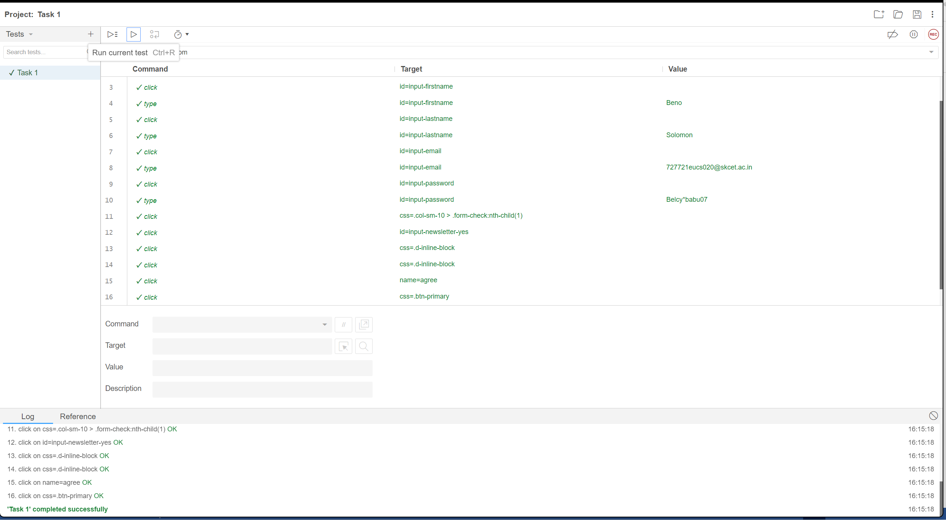

**Output:**

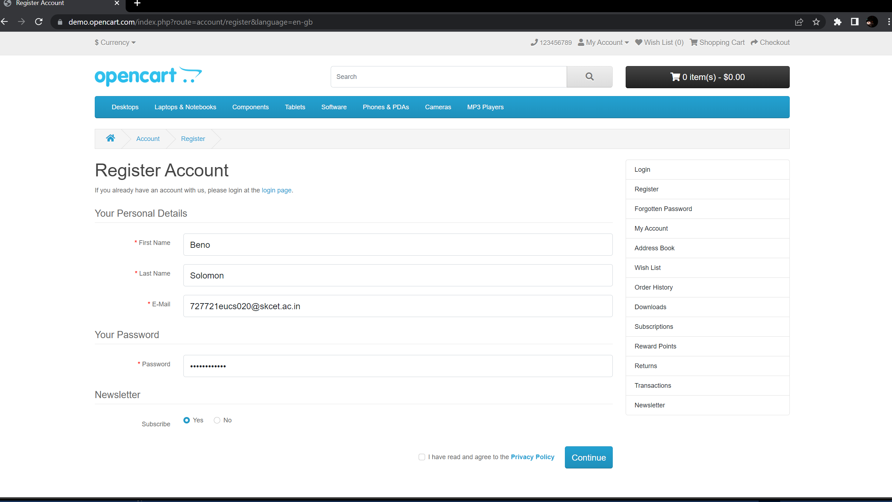

**Task 02: Locators**

package test;

import org.openqa.selenium.By;

import org.openqa.selenium.JavascriptExecutor;

import org.openqa.selenium.WebDriver;

import org.openqa.selenium.WebElement;

import org.openqa.selenium.chrome.ChromeDriver;

import org.openqa.selenium.chrome.ChromeOptions;

public class Task2 {

public static void main(String[] args) {

//WebDriverManager.chromedriver().setup();

System.setProperty("webdriver.chrome.driver","c://Drivers//chromedriver.exe" );

ChromeOptions co=new ChromeOptions();

co.addArguments("--remote-allow-origin=*");

WebDriver driver=new ChromeDriver(co);

driver.get("https://demo.opencart.com/index.php?route=account/register&language=en-gb");

WebElement fname=driver.findElement(By.id("input-firstname"));

fname.sendKeys("Beno");

WebElement lname=driver.findElement(By.id("input-lastname"));

lname.sendKeys("Solomon");

WebElement email=driver.findElement(By.id("input-email"));

email.sendKeys("beno@gmail.com");

WebElement passkey=driver.findElement(By.id("input-password"));

passkey.sendKeys("beno123");

JavascriptExecutor js = (JavascriptExecutor) driver;

js.executeScript("window.scrollBy(0,850)", "");

WebElement subscribe =driver.findElement(By.id("input-newsletter-yes"));

subscribe.click();

}

}

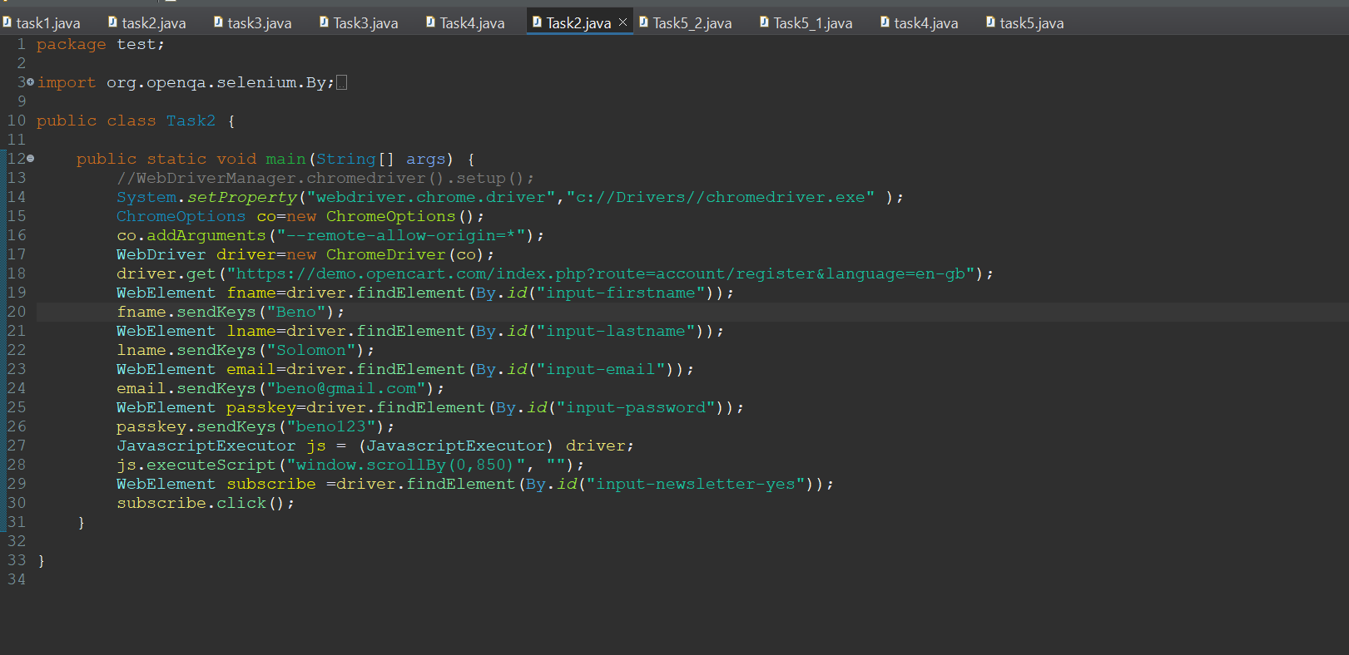

**Output:**

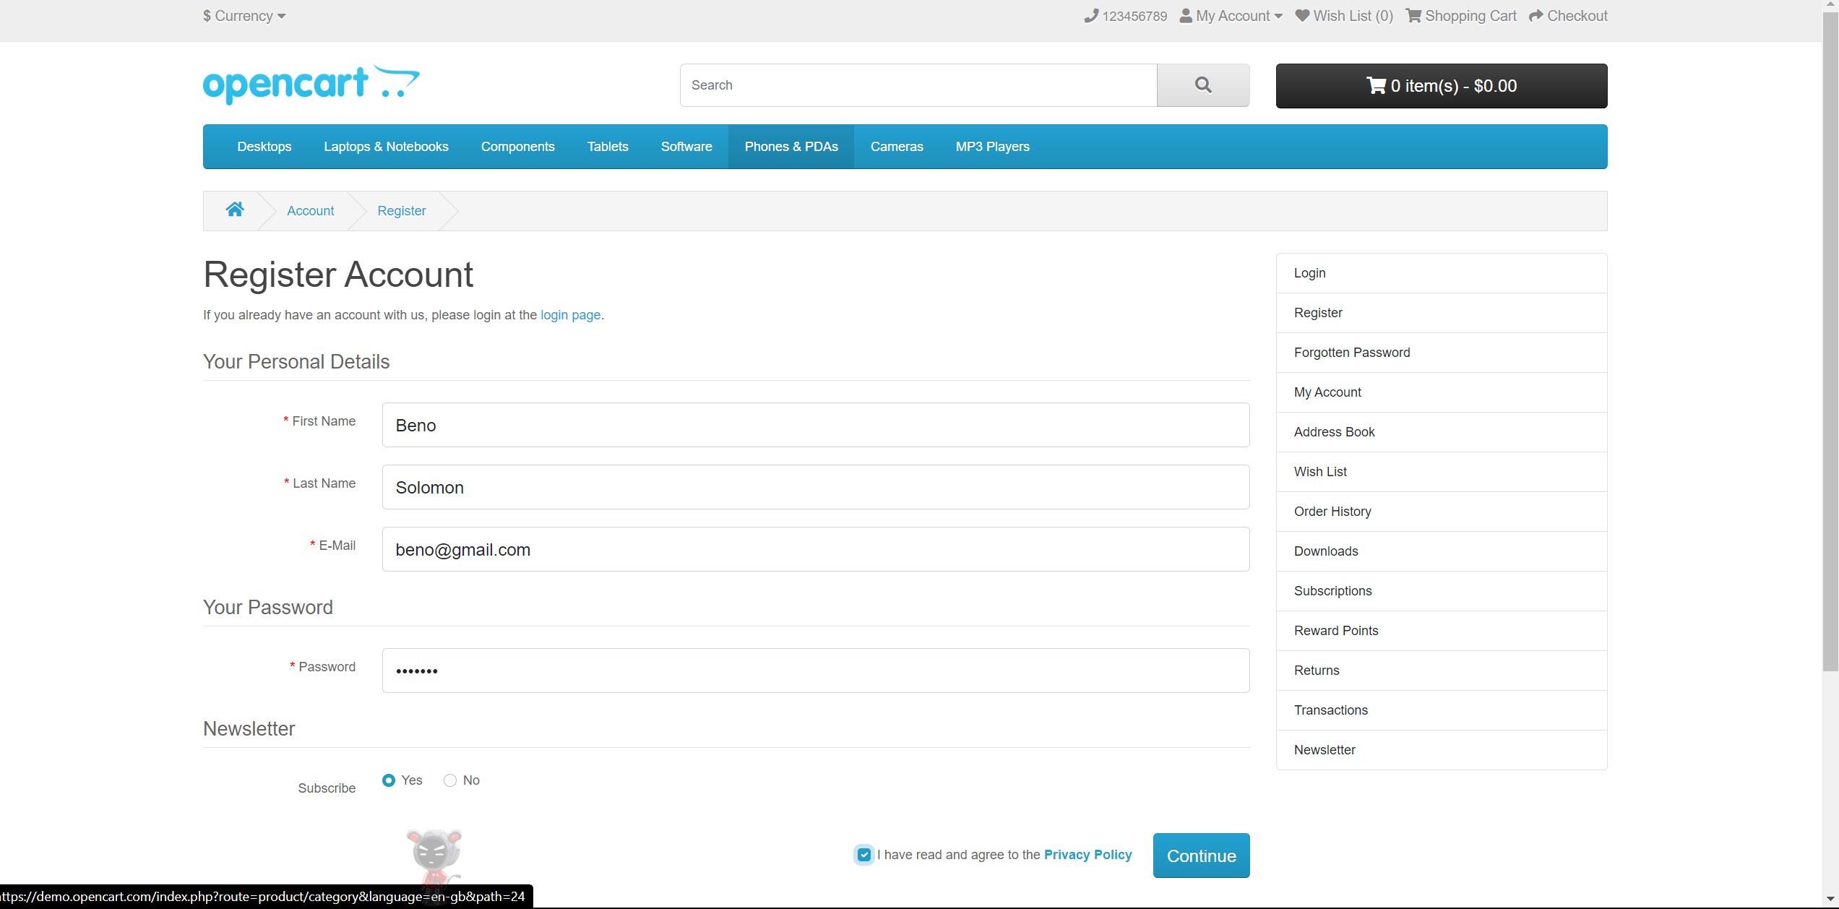

**Task 3: Locate the Below Elements withXpath**

**Coding:**

package test;

import org.openqa.selenium.By;

import org.openqa.selenium.JavascriptExecutor;

import org.openqa.selenium.WebDriver;

import org.openqa.selenium.WebElement;

import org.openqa.selenium.chrome.ChromeDriver;

import org.openqa.selenium.chrome.ChromeOptions;

public class Task3 {

public static void main(String[]args) {

//WebDriverManager.chromedriver().setup();

System.setProperty("webdriver.chrome.driver","c://Drivers//chromedriver.exe" );

ChromeOptions co=new ChromeOptions();

co.addArguments("--remote-allow-origin=*");

WebDriver driver=new ChromeDriver(co);

driver.get("https://demo.opencart.com/index.php?route=checkout/voucher&language=en-gb");

WebElement rname=driver.findElement(By.xpath("//*[@id=\"input-to-name\"]"));

rname.sendKeys("Beno");

WebElement remail=driver.findElement(By.xpath("//*[@id=\"input-to-email\"]"));

remail.sendKeys("123@gmail.com");

JavascriptExecutor js=(JavascriptExecutor)driver;

js.executeScript("window.scrollBy(0,350)","");

WebElement name=driver.findElement(By.xpath("//*[@id=\"input-from-name\"]"));

name.sendKeys("Beno");

WebElement email=driver.findElement(By.xpath("//*[@id=\"input-from-email\"]"));

email.sendKeys("abc@gmail.com");

WebElement radio=driver.findElement(By.xpath("//*[@id=\"input-theme-6\"]"));

radio.click();

WebElement msg=driver.findElement(By.xpath("//*[@id=\"input-message\"]"));

msg.sendKeys("abc");

WebElement amt=driver.findElement(By.xpath("//*[@id=\"input-amount\"]"));

amt.clear();

amt.sendKeys("7");

WebElement chk=driver.findElement(By.xpath("//*[@id=\"form-voucher\"]/div[8]/div/div/input"));

chk.click();

WebElement sub=driver.findElement(By.xpath("//*[@id=\"form-voucher\"]/div[8]/div/button"));

sub.click();

}

}

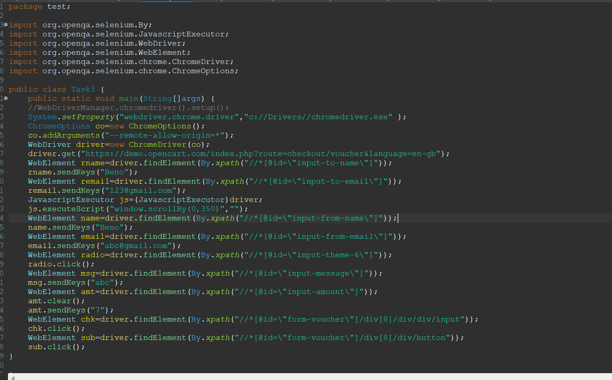

**Output:**

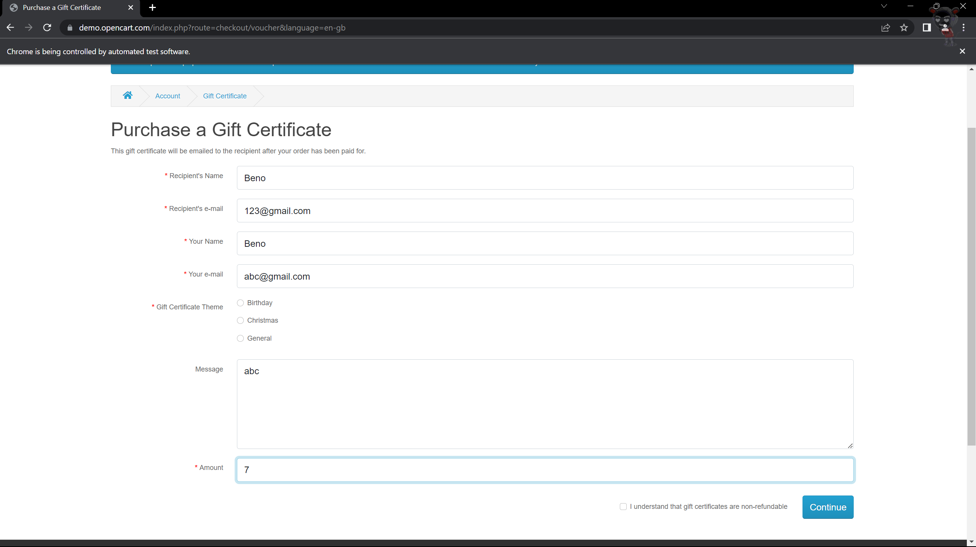

**Task 04: Web Navigation Commands**

**Coding:**

package test;

import org.openqa.selenium.By;

import org.openqa.selenium.JavascriptExecutor;

import org.openqa.selenium.WebDriver;

import org.openqa.selenium.WebElement;

import org.openqa.selenium.chrome.ChromeDriver;

import org.openqa.selenium.chrome.ChromeOptions;

import io.github.bonigarcia.wdm.WebDriverManager;

public class Task4 {

public static void main (String[] args) {

//WebDriverManager. chromedriver () . setup () ;

System.setProperty("webdriver.chrome.driver","c://Drivers//chromedriver.exe" );

WebDriver driver;

ChromeOptions co =new ChromeOptions () ; co.addArguments("--remote-alilow-origins*");

driver=new ChromeDriver (co);

driver.navigate().to ("https://j2store.net/free/");

driver.manage () .window () .maximize () ;

WebElement clothing=driver.findElement (By.xpath(" //*[@id=\"Mod112\"]/div/div/ul/li[1]/h4/a"));

clothing.click ();

driver.manage().window().maximize();

driver .navigate () .back ();

driver.navigate () . forward() ;

driver.navigate () . refresh () ;

driver.close ();

}

}

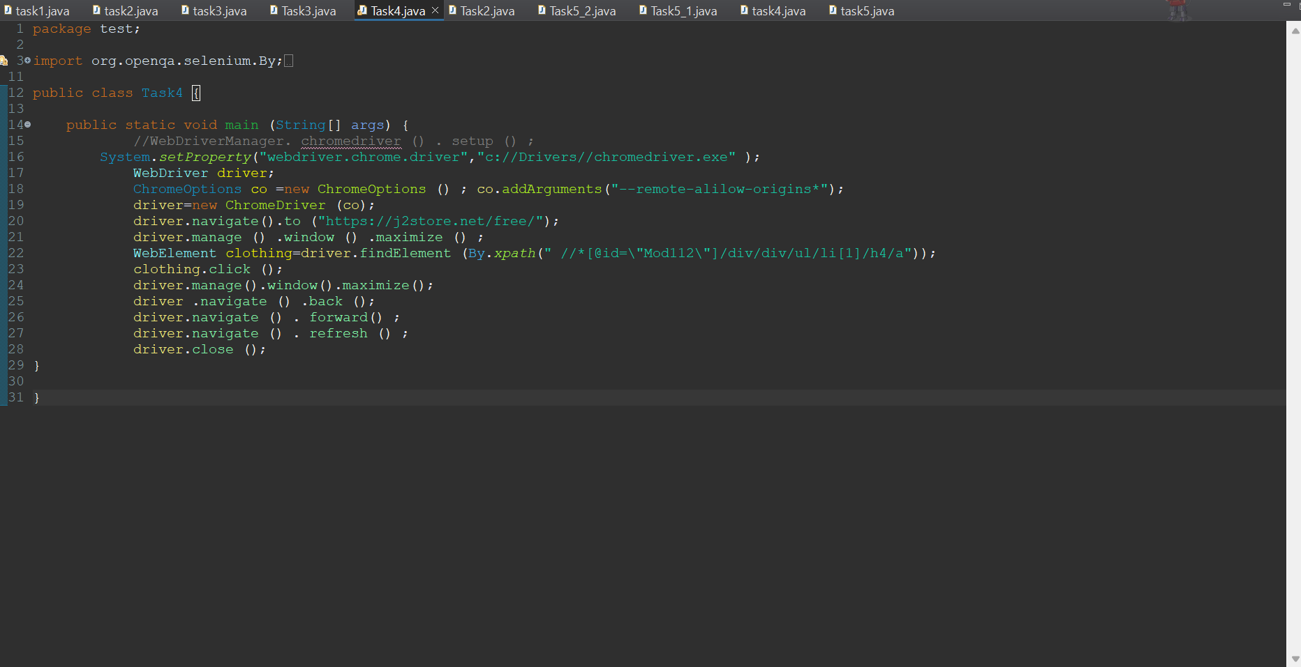

**Output:**

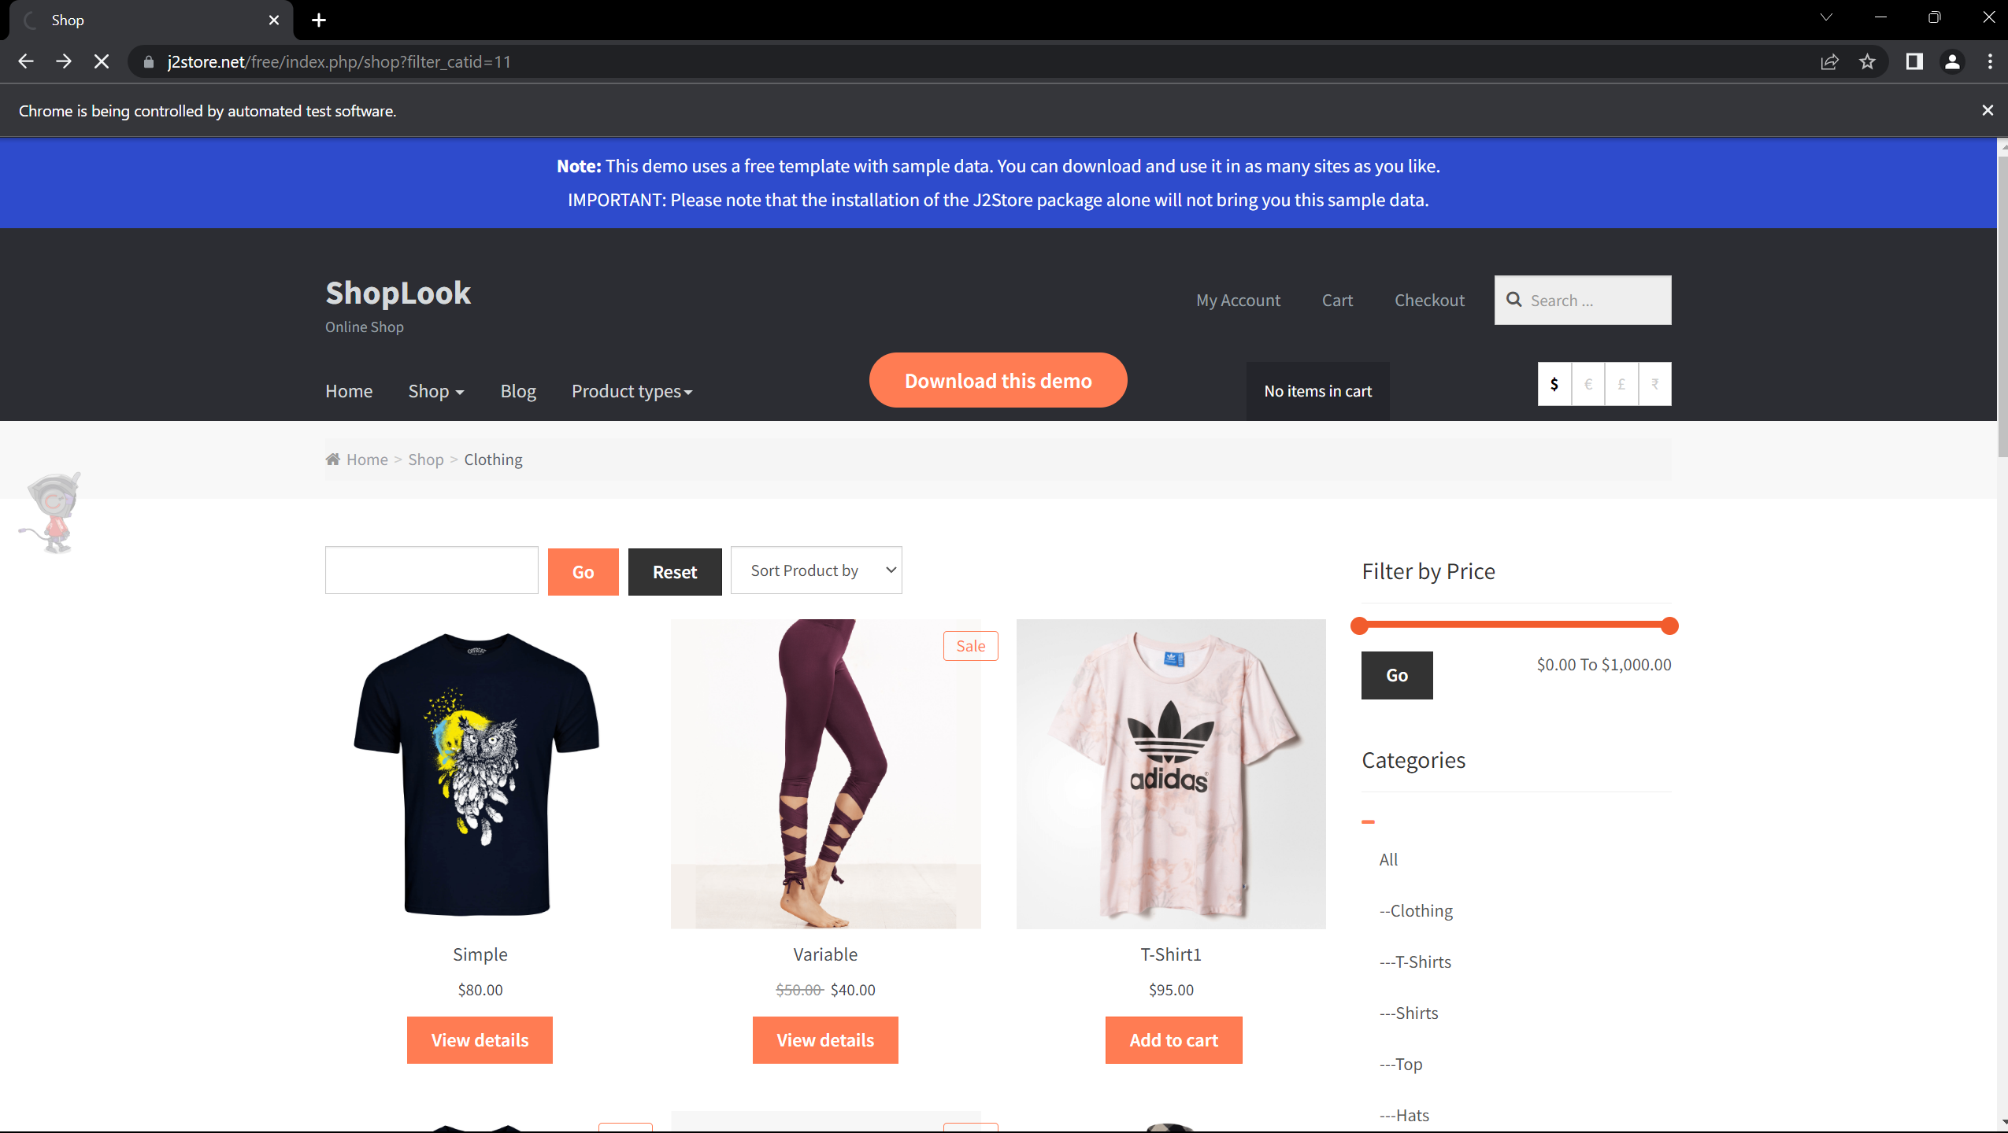

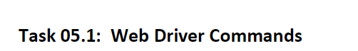

**Coding:**

package test;

import org.openqa.selenium.By;

import org.openqa.selenium.WebDriver;

import org.openqa.selenium.WebElement;

import org.openqa.selenium.chrome.ChromeDriver;

import org.openqa.selenium.chrome.ChromeOptions;

public class Task5_1{

public static void main (String [] args) {

System.setProperty("webdriver.chrome.driver","c://Drivers//chromedriver.exe" );

//WebDriverManager.chromedriver () . setup () ;

WebDriver driver;

ChromeOptions co = new ChromeOptions () ;

co.addArguments ("--remote-allow-origins=*");

driver=new ChromeDriver (co) ;

driver.get ("https://j2store.net/free/");

String url1=driver.getCurrentUrl();

if (url1.equals ("https://j2store.net/free/") )

System. out.println ("url validated");

WebElement clothing=driver.findElement (By. xpath ("//* [@id=\"Mod112\"]/div/div/ul/li[1]/h4/a"));

clothing.click ();

url1=driver.getCurrentUrl () ;

if (url1.equals ("https://j2store.net/free/index.php/shop?filter_catid=11"))

System.out. println ("url validated");

}

}

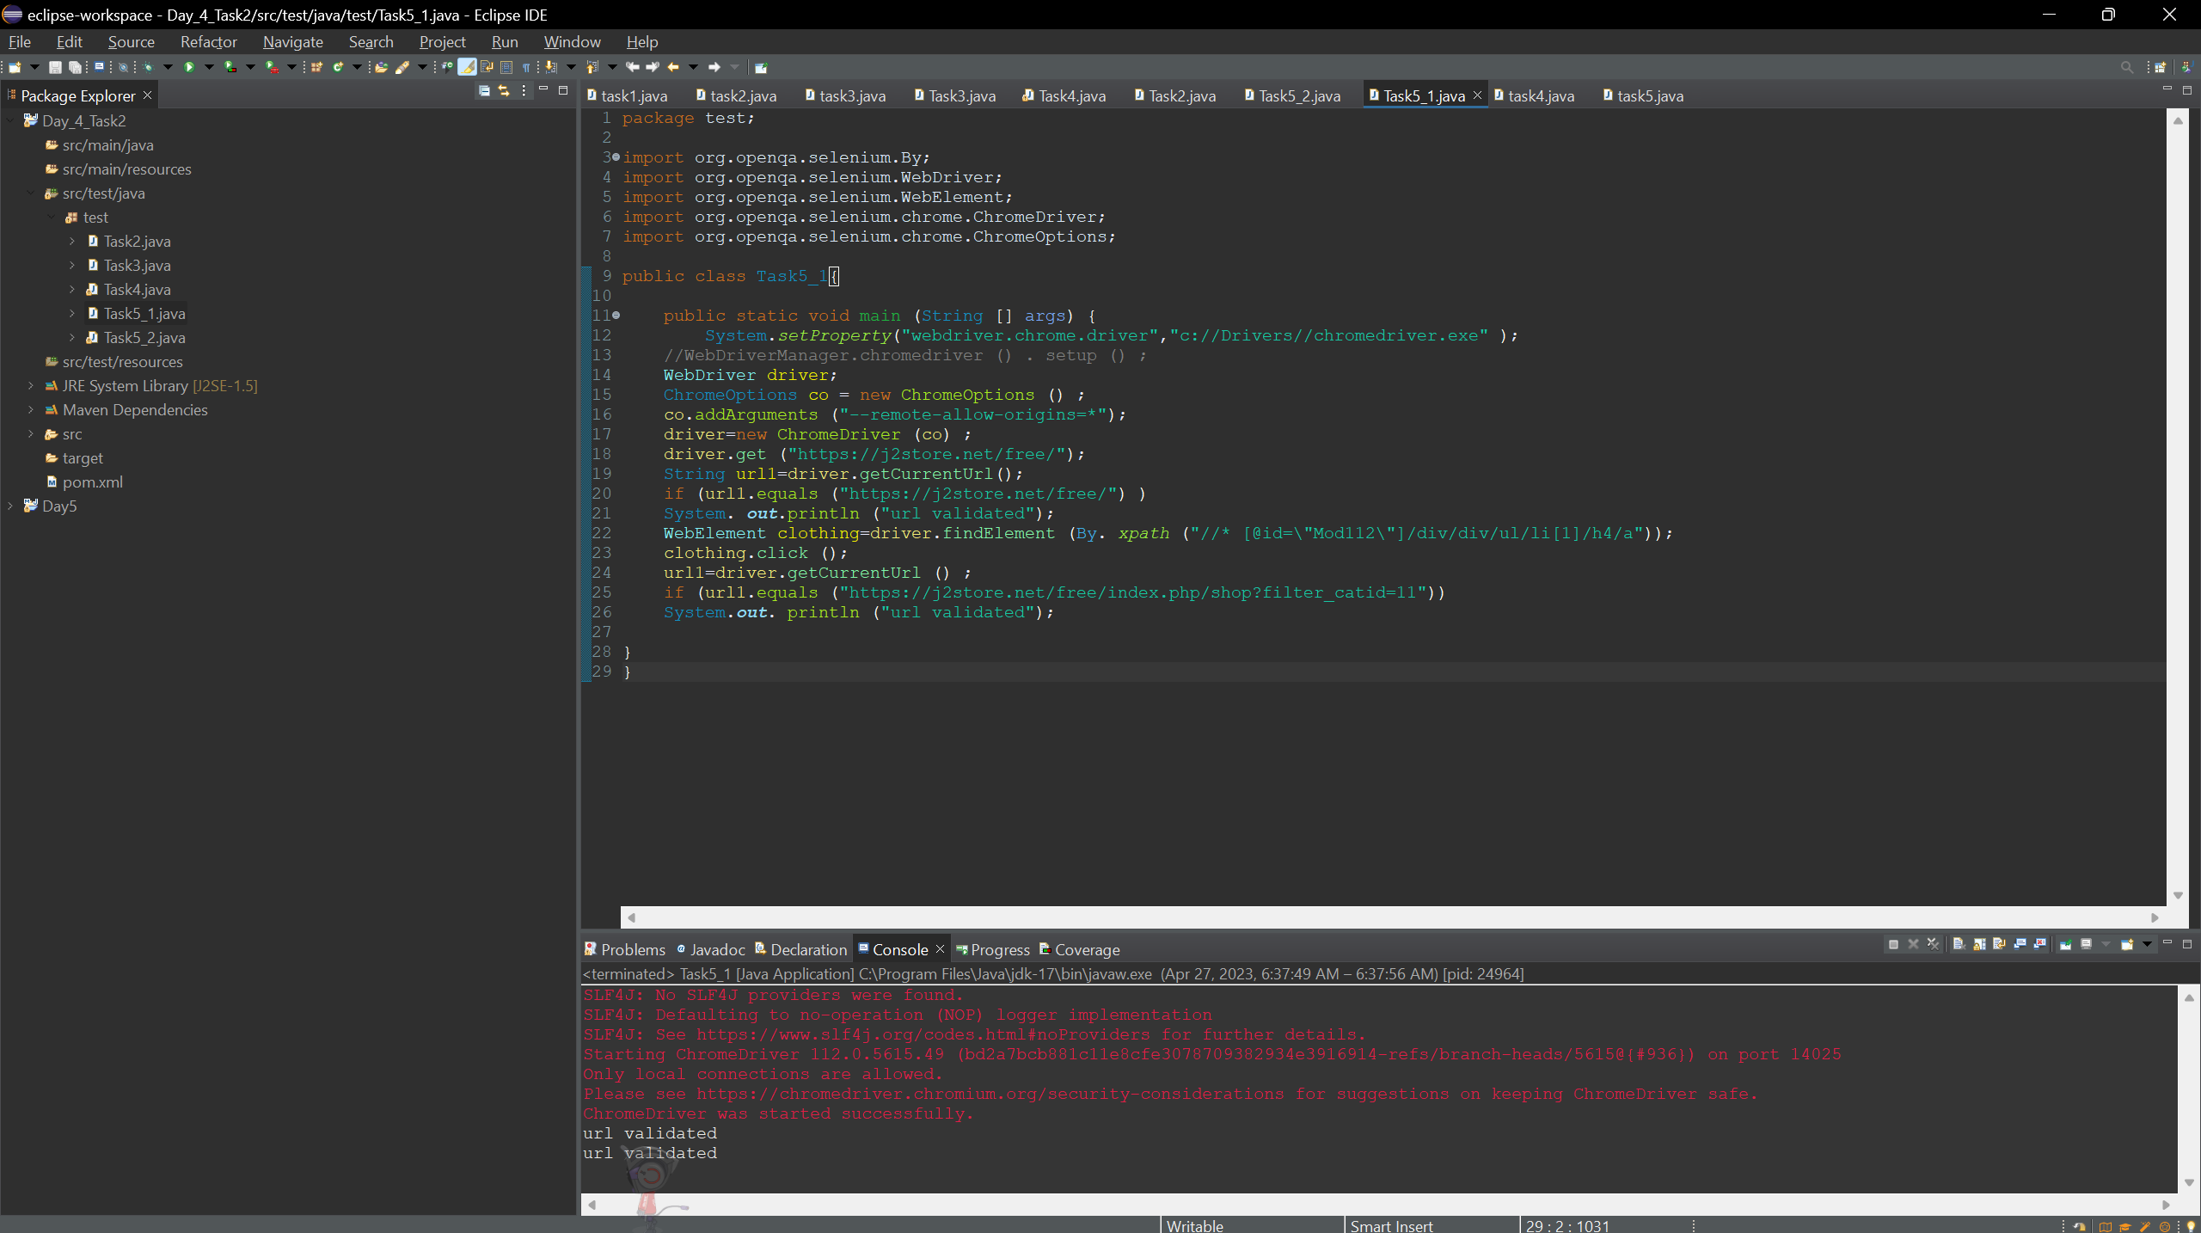

**Output:**

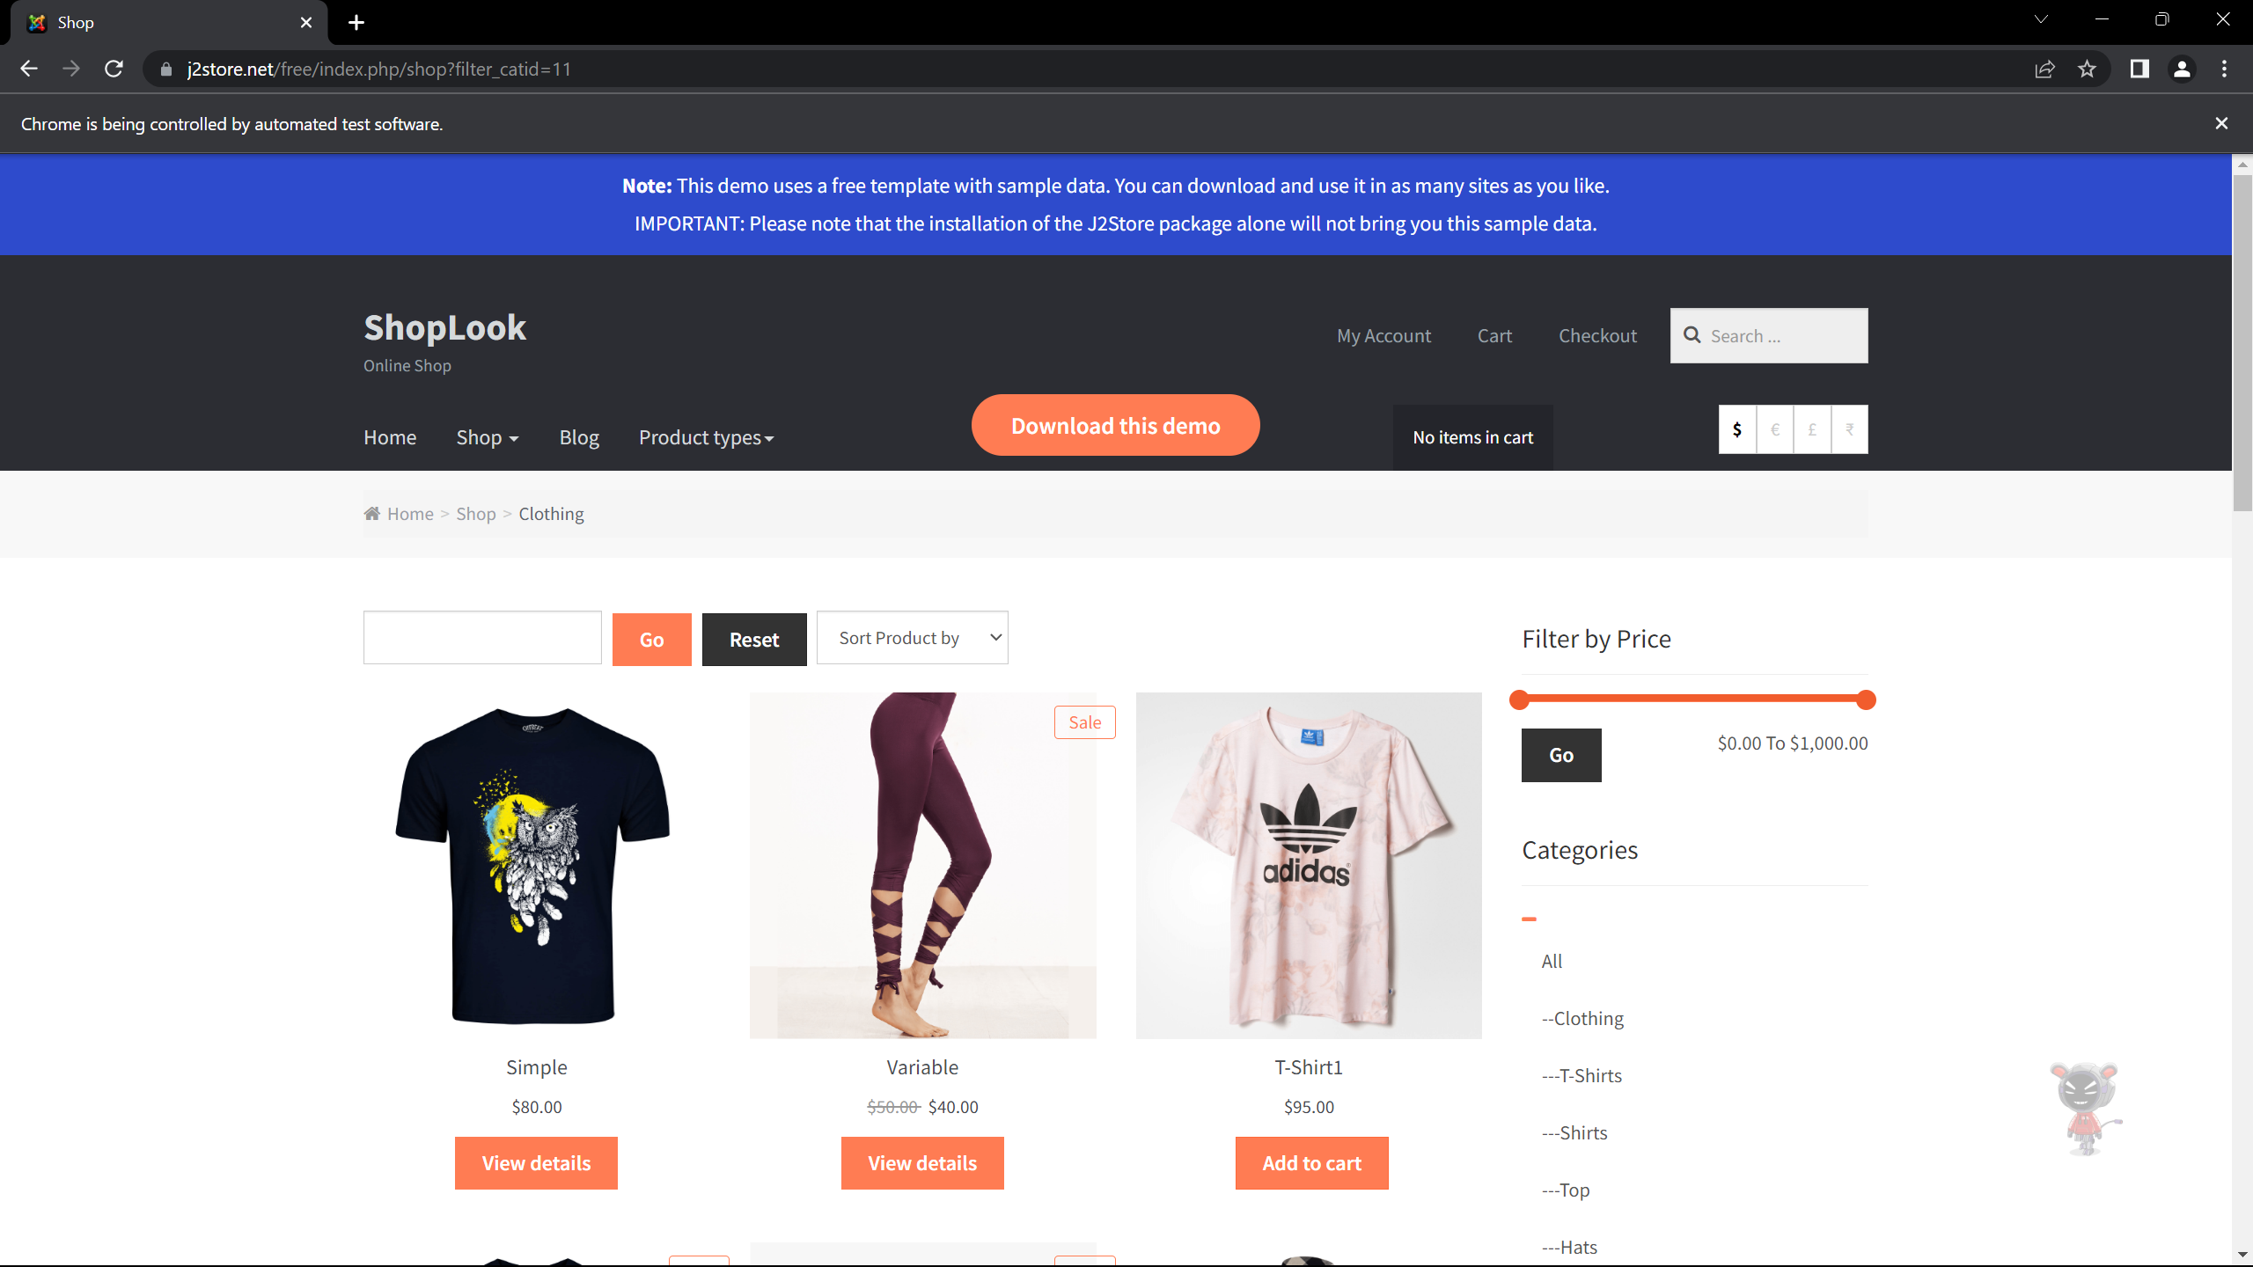

**Task 5.2: Web Driver Commands**

**Coding:**

package test;

import java.util.Iterator;

import java.util.List;

import org.openqa.selenium.By;

import org.openqa.selenium.JavascriptExecutor;

import org.openqa.selenium.WebDriver;

import org.openqa.selenium.WebElement;

import org.openqa.selenium.chrome.ChromeDriver;

import org.openqa.selenium.chrome.ChromeOptions;

import io.github.bonigarcia.wdm.WebDriverManager;

public class Task5_2 {

public static void main(String[] args) throws InterruptedException

{

//WebDriverManager.chromedriver().setup();

System.setProperty("webdriver.chrome.driver","c://Drivers//chromedriver.exe" );

ChromeOptions co = new ChromeOptions();

co.addArguments("--remote-allow-origins=*");

WebDriver driver = new ChromeDriver(co);

driver.get("https://j2store.net/free/");

driver.manage().window().maximize();

JavascriptExecutor js=(JavascriptExecutor)driver;

js.executeScript("window.scrollBy(0,1000)","");

driver.findElement(By.linkText("Clothing (5)")).click();

Thread.sleep(5000);

List<WebElement> l1 = driver.findElements(By.xpath("//h2[@class='product-title']"));

for(WebElement link : l1)

{

System.out.println(link.getText());

}

}

}

**Output:**

